**LINEAR ALGEBRA**

Laboratory Activity No. # 4

**VECTOR OPERATIONS**

**(Supplementary Activity)**

|  |
| --- |
|  |

Score

|  |  |  |  |  |
| --- | --- | --- | --- | --- |
| **CRITERIA** | **Exceeds Expectations** | **Meets Expectations** | **Needs Improvement** | **Unsatisfactory** |
| Functionality  (60 points) |  |  |  |  |
| Completeness  (20 points) |  |  |  |  |
| Structure  (20 points) |  |  |  |  |

**Remarks:**

*Submitted by:*

**Ugot, Aaron Paul M.**

**<Monday 7:00-10:00> / <58013>**

*Submitted to*

**<Ms. Maria Rizette Sayo>**

<Facilitator>

*Date Performed:*

**14-10-2023**

*Date Submitted*

**15-10-2023**

**Objective**

1. Recall knowledge on vector operations while being familiar with new operations such as products.
2. Solve vector operations using the given values.
3. Perform vector operations using Python.

**Algorithm**

1. Type the main title of this activity as "Vector Operations and Its Applications”
2. On your GitHub, create a repository name Linear Algebra 58013
3. On your Colab, name your activity as Python Exercise 4.ipynb and save a copy to your GitHub repository

**Coding Activity 4**

Code the following vector operation and solve them using the given vector values

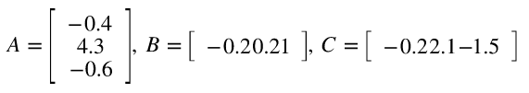

Create a program flowchart for your algorithm and explain it in your methodology. In your results, compare your answer to the expected output, visualize, and explain the resulting vector using a 3D plot.

